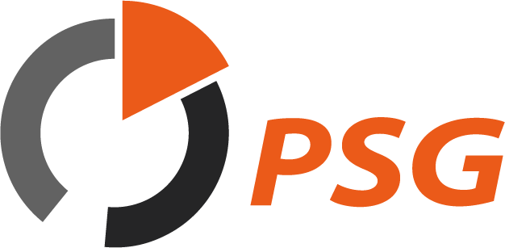
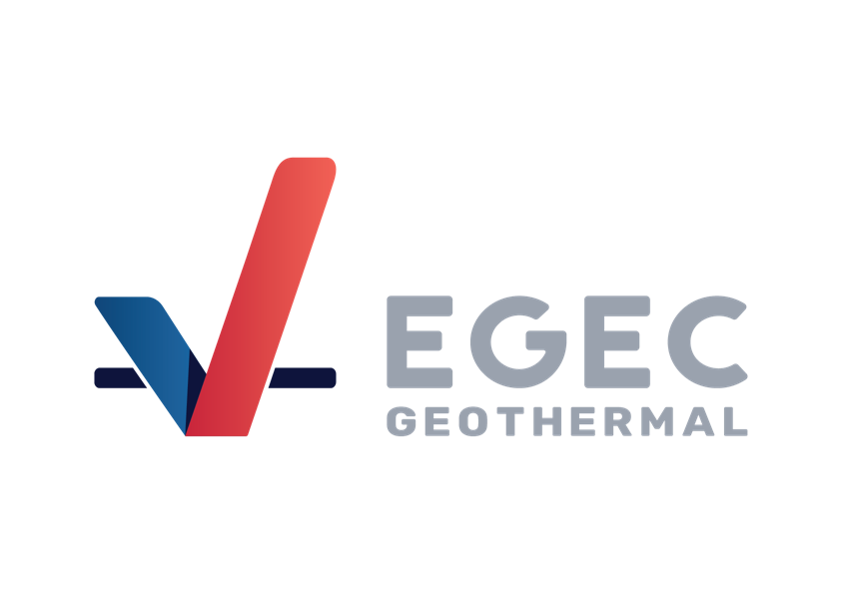
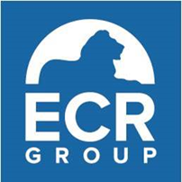

International conference
Unlocking Geothermal Potential in the EU

Date
Friday 12 April 2024, 10:00-17:30
Venue
Hotel Andersia
Plac Władysława Andersa 3
Poznań, Poland

Programme
(Interpretation: EN, PL)

09:30-10:00 | Welcome coffee

10:00-10:30 | Welcome address and opening speeches
  - Professor Zdzisław Krasnodębski, Member of the European Parliament, Poland
  - Viktor Horváth, Deputy State Secretary for Energy Transition, Hungary
  - Professor Krzysztof Galos, Undersecretary of State, Chief National Geologist, Poland

10:30-12:00 | First panel discussion | EU policy and prospects for further development of the geothermal energy in Europe
  - Professor Zdzisław Krasnodębski, MEP, EP rapporteur on geothermal energy
  - Pernille Weiss, MEP, EPP shadow rapporteur on geothermal energy, Denmark
  - Barbara Głowacka, Member of Cabinet of Kadri Simson, EU Commissioner for Energy
  - Sanjeev Kumar, Head of Policy, European Geothermal Energy Council (EGEC), Brussels
Moderator: Wojciech Jakóbik, BiznesAlert.pl

12:00-13:00 | Lunch break

13:00-14:30 | Second panel discussion | Geothermal in cities and regions
  - József Ribányi, European Committee of the Regions rapporteur on "Localising energy production: the role of geothermal energy", Hungary
  - Mikołaj Gajsler, Business Development Lead, Innargi, Poznań
  - Marek Hajto, Deputy chairman of the Polish Geothermal Society (PSG)
  - Sanja Živković, Ph.D, Energy Institute Hrvoje Požar, Croatia
  - René Verhoeven, Post Mining Exploitation Lead, Fraunhofer IEG, Germany
Moderator: Wojciech Jakóbik, BiznesAlert.pl

14:30-15:00 | Coffee break

15:00-16:30 | Third panel discussion | Industrial policy and finance
  - Veronica Wänman, Investment Manager Europe, Baseload Capital, Sweden
  - Adam Calicki, Managing Director, Sustainable Power Solutions ehf., Island
  - Juan Carlos Afonso, Ph.D, Associate Professor, Coordinator of the Earth Safe PhD programme in geothermal, University of Twente, Netherlands
  - Horst Kreuter, PhD, Founder & General Representative, Vulcan Energy Resources GmBH, Germany
  - Arkadiusz Biedulski, CEO, UOS Drilling, Deputy chairman of the Polish Geothermal Society (PSG)
Moderator: Wojciech Jakóbik, BiznesAlert.pl

16:30-17:30 | Networking cocktail

* * *

